Company Project Form
Company Information
Company Name: ACME MICRO TURBINE INDUSTRIES

Company Address: 10000XX Delft

Company Supervisor Name: Mr. XXXXXXXX

Title/position: Technical Project Manager, Turbomachinery Division

e-mail: XXXXXX@acme_turbines.nl

Phone number (optional): XXXXXXXXXX
Yes No

a) The company supervisor is available to discuss progress with students on a regular ☒ ☐ basis (once a week is recommended)

b) The company supervisor is available between September 2020 and January 2021 ☒ ☐ to supervise the project

c) The students can occasionally come and work at the company location (once a month ☒ ☐ is recommended)

Comments/Observations:
- The supervisor is expected to take one week of leave in October 2019. During that period, a different colleague can address questions from students.
- The students can work on the company premises, but only on request from the students and notice has to be given 2 weeks in advance to reserve a room. Students have access only to the office space but not to the manufacturing facilities.

Project Information
Project Title
Micro Gas Turbine for Combined Heat and Power
Project Background
ACME TURBINES is a company located in Delft which designs and manufactures the XENGINE gas turbine. This is a bypass turbofan and it is originally designed as propulsion system for a small aircraft. In the previous 3 years ACME TURBINES realized that there is an emerging market in Europe for small electricity and heat generating units. The output requirements of these units are similar to the output delivered by the XENGINE gas turbine.
The purpose of this project is to determine the feasibility of converting the XENGINE turbofan into a stationary heat and power unit (CHP) (Figure 1). The purpose of the assignment is to do an in-depth design and process optimization of a micro combined heat and power (CHP) cycle using the XENGINE as its starting driver.
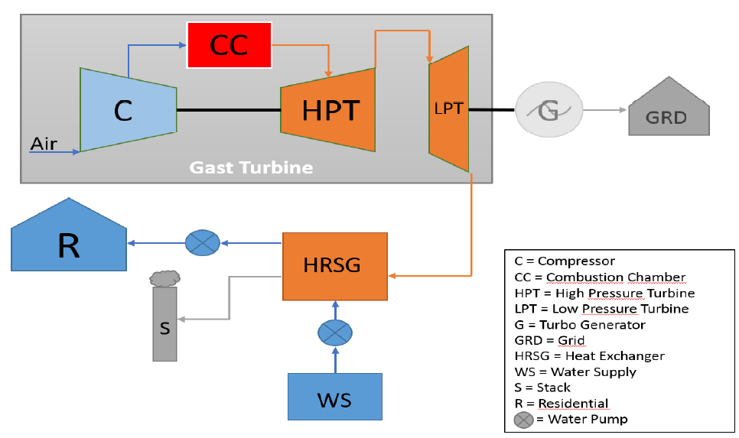
Figure 1. Micro CHP unit schematic.
Project Goal and Deliverables
The purpose of this project is to determine the feasibility of converting the XENGINE turbine into a stationary heat and power unit (CHP). Concretely, a preliminary design, sizing and operating cost of the unit should be determined. Furthermore, a market study should be performed in order to determine if the unit is economically competitive. Project deliverables:

- Conceptual design of micro CHP unit including flows, temperatures and pressures.
- Market survey of micro CHP units in the Netherlands and Europe.
- Unit size estimate and CAD drawing
- Operational expenditures (OPEX) estimate for different seasons of the year
- Final report and presentation.

General list of activities
- Literature survey and familiarization with GSP/Gasturb software and the XENGINE (0.5 month)
  - Review the previous work done in the field and prepare a project plan
  - Get familiar with the Gasturb and GSP commercial software packages
  - Explore alternatives within the European market for micro CHP
- Optimize the Gas turbine cycle of the XENGINE (3 months)
  - Review the basic configuration of a micro CHP using the XENGINE data
  - Make a thermodynamic analysis of the system and optimize the process configuration
  - Perform an OPEX estimate of the system under different operating conditions
- Sizing of the system and CAD drawing (1.5 months)
  - Perform a basic system design and size the main components including piping and heat exchangers. Excel or MATLAB can be used.
  - Draw the final system in CAD and perform a weight estimate.
- Write report
Project Confidentiality
Yes No
a) Must the students and university supervisor sign a confidentiality agreement before ☒ ☐ starting this project?

(If yes, the agreement should be ready before September 2019 so the students can start in time)
Comments
The students are expected to visit the company at least once every two weeks to discuss progress and to use the software available at ACME MICROTURBINES.

The market study can be performed in collaboration with the ACME’s business development department.
Attachments
- XENGINE specification
- XENGINE commercial flyer
- ……

